# CHAPTER: 1

## Introduction

India is the country of village and agriculture plays an important role for development of country. In our country, agriculture depends on the monsoons which has insufficient source of water. So the irrigation is used in agricultural field In Irrigation system, depending upon the soil type, water is provided to plant. In agriculture, two things are very important, first to get information of about the fertility of soil and second to measure humidity content in air. Nowadays, for irrigation, different techniques are available which are used to reduce the dependency of rain. And mostly this technique is driven by electrical power and on/off scheduling. In this technique, an temperature and humidity sensors are placed near the plant and near the module and gateway unit handles the sensor information and transmit data to the controller which in turns the control the flow of water through the pump.

## Motivation

For continuously increasing demand and decrease in supply of food necessities, it’s important to rapid improvement in production of food technology. Agriculture is only the source to provide this. This is the important factor in human societies to growing and dynamic demand in food production. Agriculture plays the important role in the economy and development, like India. Due to lack of water and scarcity of land water result the decreasing volume of water on earth, the farmer use irrigation. Irrigation may be defined as the science of artificial application of water to the land or soil that means depending on the soil type, plant are to be provided with water.

* 1. ***Objective Of The Project***

## Prevent Disease and Weeds

Specialized drip irrigation systems direct water specifically to each plant's

root ball, rather than sprinkling the entire garden like a typical rainstorm. As a result, surrounding weed seeds cannot germinate, so you'll have less weeding to do. Water at the roots also prevents leaf diseases caused by standing droplets on the foliage. Because the water does not strike the leaves or flowers, blight diseases have no chance of proliferating.

## Conserves Water and Time

Hand watering with a hose or watering can takes substantial time and early morning and evening watering rituals take away from family and work. Both drip and sprinkler irrigation systems have sensors that can be pre-set for daily or weekly watering so you do not need to monitor the watering because the soil moisture sensor shuts the water off when the soil gets perfect moisture. Your water bill should be lower if the irrigation system is effective.

## Prevent Soil Structure and Nutrients

Watering with a wide open garden hose may allow too much water to seep into the soil. As a result, nutrients leach out with the water runoff, leaving the plants with fewer nutrients available. The soil may also become compacted when you water with a hose. Plants may show signs of withering or root disease with suffocating, compacted soil. Using either drip or sprinkler irrigation produces smaller droplets, helping to preserve nutrients and reducing soil compaction.

## Gardening Flexibility

If you have a busy schedule, you'll appreciate being able to work in the garden at the same time as the plants are being watered. While one garden section is being watered, you can plant and prune in another area.

# CHAPTER: 2

Primary investigation is carried out under the following stages, such as Understanding the existing approaches, Understanding the requirements, Developing an abstract for the system.

In this project, soil moisture sensor placed in root zone of plant and transmit data to arduino. Threshold value of soil moisture sensor that was programmed into a microcontroller to control water quantity. This project on "Automatic Irrigation System with Fertility indicator" is intended to create an automated irrigation mechanism which turns the pumping motor ON and OFF on detecting the dampness content of the earth. In this project only soil moisture value is considered but proposed project provided extension to this existed project by adding temperature and humidity values.

This proposed project is arduino based remote irrigation system developed for the agricultural plantation, which is placed at the remote location and required water provides for plantation when the humidity of the soil goes below the set-point value. But in this we did not aware about the soil moisture level so to overcome this drawback proposed system included with extra feature soil moisture value and temperature value which displayed on the farmer mobile application. Irrigation Control System Using GSM for Efficient Use of Water and Power. this system made use of GSM to control the system which may cost more so to overcome that proposed system used arduino which already consist of in build GSM module. Microcontroller based

*3*

Controlled Irrigation System for Plantation. In this project old generation with lesser memory microcontroller is used to control the system but proposed system made use of arduino which is user friendly and it helps to dump the programs easily. A wireless application of drip irrigation automation supported by soil moisture sensor. in this project irrigation is carried out using soil moisture values but extend to this Fertility indicator.

# CHAPTER: 3 THEORY

Currently, the world has close to 7.53 billion people. A recent study found that, on average, 33 percent of the global population suffers from water scarcity in some form or the other. By 2030, this figure is likely to rise to 50 percent, clearly underlining the alarming rate at which the problem of water deficiency is expanding. Interestingly, approximately 70 percent of the total volume of water withdrawals in the world are used for irrigation, and that’s precisely where most of the water waste happens. Around 60 percent of the water meant to be used for irrigation is lost**,** either due to evapotranspiration, land runoff, or simply inefficient, primitive usage methods. This, in turn, brings to light the importance of smart irrigation – powered by the GSM – that can go a long way in managing the rising levels of water stress worldwide. In what follows, we will put the spotlight on some interesting facts about smart irrigation:

## 1. The Need for Automated Irrigation

Smart irrigation is a key component of precision agriculture. It helps farmers to avoid water wastage and improve the quality of crop growth in their fields by

*a) irrigating at the correct times,*

*4*

1. *minimizing runoffs and other wastages, and*
2. *determining the soil moisture levels accurately,*

thereby, finding the irrigation requirements at any place. Replacing manual irrigation with automatic valves and systems also does away with the human error element e.g. forgetting to turn off a valve after watering the field and is instrumental in saving energy, time, and valuable resources. The installation and configuration of smart irrigation systems is, in general, fairly straightforward, too.

# CHAPTER: 4

## CIRCUIT DETAILS

* 1. ***Block Diagram***

*Power Supply*



*Probes to soil*



*Arduino uno*

*GSM*

*Color Sensor*

*5*

*Moisture Sensor Circuit*



*Relay*

# Figure:1 Block Diagram

## CIRCUIT DIAGRAM

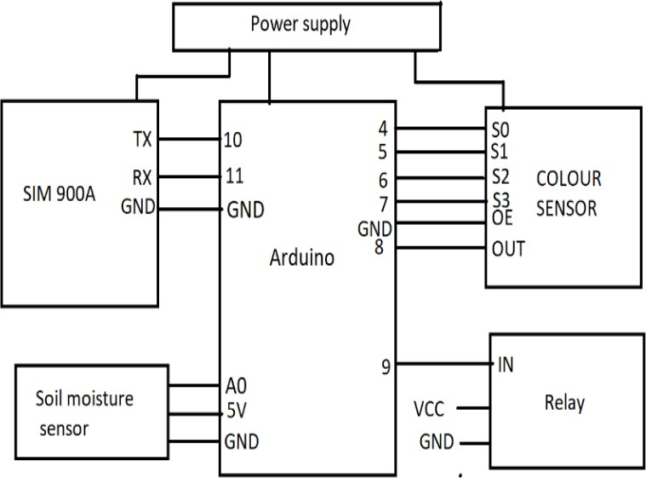

***Figure:2 Circuit Diagram***

* 1. ***List of Component Table:1 List of component***

|  |  |  |
| --- | --- | --- |
| *Sr.No* | *Component Name* | *Quantity* |
| *1* | *Arduino* | *1* |
| *2* | *SIM 900A GSM Module* | *1* |
| *3* | *Colour Sensor TCS 3200* | *1* |
| *4* | *Soil Moisture Sensor* | *1* |
| *5* | *Soil Testing Kit* | *1* |
| *6* | *Water Pump* | *1* |
| *7* | *Toggle Switch* | *3* |
| *8* | *Adaptor* | *2* |

***CHAPTER: 5 WORKING***

The working of this project start from first it collect output from the soil with the help of probes and send it to arduino. This value is collected by arduino & arduino process the information and then decide to send related information to the GSM.

Then the GSM send us massage according to the status of water pump.

The ON and OFF of the water pump is decided by arduino in according with the program write in arduino. If need to be switch ON arduino give a signal to relay module to start the water pump and also sand SMS to us .

## To check fertility of soil

To test soil nutrients there are three type of formulated capsule i.e nitrogen, phosphorous, potassium. These capsules chemical react with soil nutrients and appear colour of different intensity. These intensity of colour is detected by colour sensor and give us information about nutrients.

Before use colour sensor we have to do some process.

Mix soil with water with 1:2 ratio in volume and mix it thoroughly. Wait 10-30

min for settling soil in bottom and clear water separation.

**Nitrogen testing :-** open nitrogen testing capsule put the chemical inside the test tube and transfer 4 ml of clear soil extract with dropper. Cap it and mix gently until the chemical is dissolved. Wait 20 minutes for the colour to develop. After this put colour sensor on test tube the colour sensor sense the colour and sand it to arduino. Arduino decide the content of nitrogen in soil and send it to us using GSM through SMS

**phosphorous testing :-** open phosphorous testing capsule put the chemical inside the test tube and transfer 4 ml of clear soil extract with dropper and add 4 drop of TCA reagent. Cap it and mix gently until the chemical is dissolved. Wait 20 minutes for the colour to develop. After this put colour sensor on test tube the colour sensor sense the colour and sand it to arduino arduino decide the content of phosphorous in soil and send it to us using GSM through SMS

**Potassium testing :-** open potassium testing capsule put the chemical inside the test tube and transfer 4 ml of clear soil extract with dropper. Cap it and mix gently until the chemical is dissolved. Wait 20 minutes for the colour to develop. After this put colour sensor on test tube the colour sensor sense the colour and sand it to arduino. arduino decide the content of potassium in soil and send it to us using GSM through SMS.

# CHAPTER: 6

***Source Code:***

## #include <SoftwareSerial.h>

***SoftwareSerial SIM900A(10,11); int K;***

***int P; int N; int mos;***

***#define S0 4***

***#define S1 5***

***#define S2 6***

***#define S3 7***

***#define sensorOut 8 #define soil A0 #define phosphours 3***

***#define nitrogen 2***

***#define potassium 12***

***#define Pump 9***

***int r = 0; int g = 0; int b = 0;***

***void setup()***

***{***

***pinMode(phosphours, INPUT); digitalWrite(phosphours,LOW); pinMode(nitrogen, INPUT); digitalWrite(nitrogen,LOW); pinMode(potassium, INPUT); digitalWrite(potassium,LOW); pinMode(S0, OUTPUT); pinMode(S1, OUTPUT); pinMode(S2, OUTPUT); pinMode(S3, OUTPUT); pinMode(soil, INPUT); pinMode (Pump, OUTPUT); digitalWrite(Pump,LOW); pinMode(sensorOut, INPUT); digitalWrite(S0,HIGH); digitalWrite(S1,LOW); Serial.begin(9600); SIM900A.begin(9600);***

***Serial.println ("SIM900A Ready"); delay(100);***

***}***

***void loop() { digitalWrite(S2,LOW); digitalWrite(S3,LOW);***

***r = pulseIn(sensorOut, LOW); Serial.print("R = "); Serial.print(r);***

***delay(100); digitalWrite(S2,HIGH); digitalWrite(S3,HIGH);***

***g = pulseIn(sensorOut, LOW); Serial.print(" G = "); Serial.print(g);***

***delay(100); digitalWrite(S2,LOW); digitalWrite(S3,HIGH);***

***b = pulseIn(sensorOut, LOW); Serial.print(" B = "); Serial.print(b);***

***delay(100);***

***mos = analogRead(soil);***

***K = digitalRead(potassium); N = digitalRead(nitrogen);***

***P = digitalRead(phosphours); if(K==HIGH)***

***{***

***if (r<150&&b<150&&g<150)***

***{***

***Serial.println ("Sending Message"); SIM900A.println("AT+CMGF=1");***

***delay(1000); SIM900A.println("AT+CMGS=\"+917004964543\"\r");***

***delay(1000);***

***SIM900A.println("potassium not required");***

***delay(100);***

***Serial.println ("potassium not required"); SIM900A.println((char)26);// ASCII code of CTRL+Z delay(10000);***

***}***

***if (r>150&&b>150&&g>150)***

***{***

***Serial.println ("Sending Message"); SIM900A.println("AT+CMGF=1");***

***delay(1000); SIM900A.println("AT+CMGS=\"+917004964543\"\r");***

***delay(1000); SIM900A.println("potassium required"); delay(100);***

***Serial.println ("potassium required"); SIM900A.println((char)26); delay(60000);***

***}***

***} if(N==HIGH)***

***{***

***if (r<225&&b<225&&g<300)***

***{***

***Serial.println ("Sending Message"); SIM900A.println("AT+CMGF=1");***

***delay(1000); SIM900A.println("AT+CMGS=\"+917004964543\"\r");***

***delay(1000);***

***SIM900A.println("nitrogen not required"); delay(100);***

***Serial.println ("nitrogen not required"); SIM900A.println((char)26); delay(10000);***

***}***

***if (r>225&&b>225&&g>300)***

***{***

***Serial.println ("Sending Message"); SIM900A.println("AT+CMGF=1");***

***delay(1000); SIM900A.println("AT+CMGS=\"+917004964543\"\r");***

***delay(1000); SIM900A.println("nitrogen required"); delay(100);***

***Serial.println ("nitrogen required"); SIM900A.println((char)26); delay(60000);***

***}***

***} if(P==HIGH)***

***{***

***if (r<310&&b<250&&g<200)***

***{***

***Serial.println ("Sending Message"); SIM900A.println("AT+CMGF=1");***

***delay(1000); SIM900A.println("AT+CMGS=\"+917004964543\"\r");***

***delay(1000);***

***SIM900A.println("phosphours not required"); delay(100);***

***Serial.println ("phosphours not required"); SIM900A.println((char)26);***

***delay(60000);***

***}***

***if (r>310&&b>250&&g>200)***

***{***

***Serial.println ("Sending Message"); SIM900A.println("AT+CMGF=1");***

***delay(1000); SIM900A.println("AT+CMGS=\"+917004964543\"\r");***

***delay(1000); SIM900A.println("phosphours required"); delay(100);***

***Serial.println ("phosphours required"); SIM900A.println((char)26); delay(10000);***

***}***

***}***

***if (mos>600)***

***{***

***digitalWrite(Pump, HIGH); Serial.println ("Sending Message"); SIM900A.println("AT+CMGF=1");***

***delay(1000); SIM900A.println("AT+CMGS=\"+917004964543\"\r");***

***delay(1000); SIM900A.println("pump on"); delay(100);***

***Serial.println ("pump on"); SIM900A.println((char)26); delay(10000);***

***}***

***if (Pump==HIGH&&mos<500)***

***{***

***digitalWrite(Pump, LOW);***

***Serial.println ("Sending Message"); SIM900A.println("AT+CMGF=1");***

***delay(1000); SIM900A.println("AT+CMGS=\"+917004964543\"\r");***

***delay(1000); SIM900A.println("pump off"); delay(100);***

***Serial.println ("pump off"); SIM900A.println((char)26); delay(10000);}***

***}***

***CHAPTER: 7***

***Breadboard Implementation***

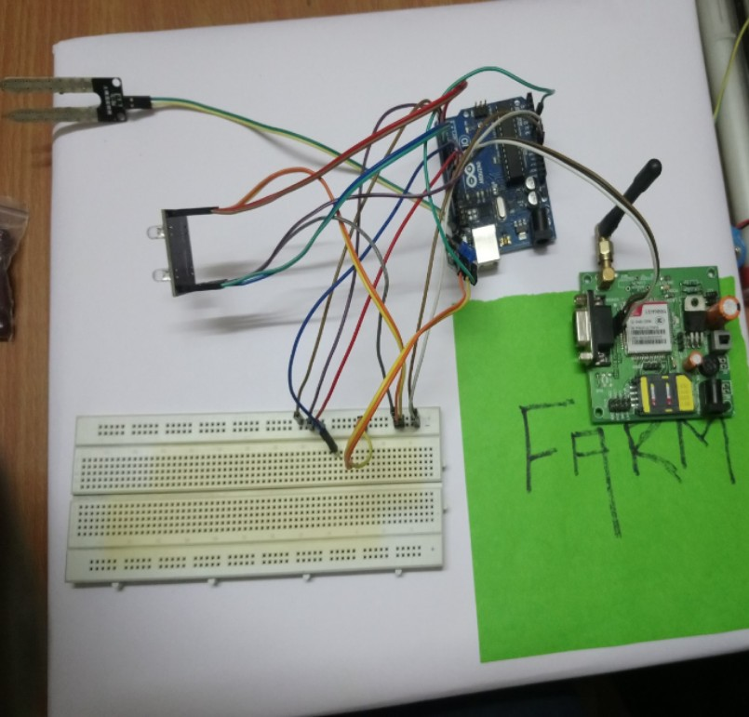

***Figure:3 Breadboard Implementation***

***CHAPTER: 8***

***Component Details:***

* 1. ***Arduino***

Arduino is an open source physical computing platform based on simple input/output board and a development environment that implements the Processing language . Arduino can be used to develop standalone interactive objects or can be connected to software on your computer. The boards can be assembled by hand or purchased preassembled; the open source IDE can be downloaded for free from [www.arduino.cc](http://www.arduino.cc/)

## Introduction to Arduino Uno Board

Arduino is an architecture that combines Atmel microcontroller family with standard hardware into a board with inbuilt boot loader for plug and play embedded programming. Arduino Software comes with an IDE that helps writing, debugging and burning program into Arduino. The IDE also comes with a Serial Communication window through which can easily get the serial data from the board.

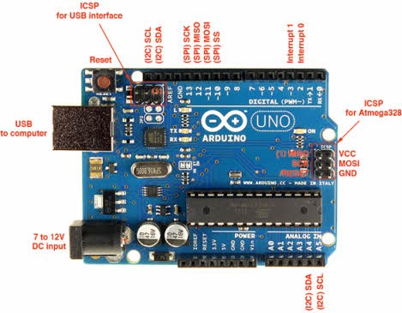

# Figure:4 Arduino Uno Board

***Table:2 Pin Description of Arduino UNO***

|  |  |  |  |
| --- | --- | --- | --- |
| ***Pin Category*** | ***Pin Name*** | | ***Details*** |
| *Power* | *Vin, 3.3V, GND* | *5V,* | *Vin: Input voltage to Arduino when using an external power source.* |
|  |  |  | *5V: Regulated power supply used to power microcontroller and other components on*  *the board.* |
|  |  |  | *3.3V: 3.3V supply generated by on-board voltage regulator. Maximum current draw is 50mA.* |
|  |  |  | *GND: ground pins.* |
| *Reset* | *Reset* | | *Resets the microcontroller.* |
| *Analog Pins* | *A0 – A5* | | *Used to provide analog input in the range of 0-5V* |
| *Input/Output Pins* | *Digital Pins 0 - 13* | | *Can be used as input or output pins.* |
| *Serial* | *0(Rx), 1(Tx)* | | *Used to receive and transmit TTL serial data.* |
| *External Interrupts* | *2, 3* | | *To trigger an interrupt.* |
| *PWM* | *3, 5, 6, 9, 11* | | *Provides 8-bit PWM output.* |
| *SPI* | *10 (SS),*  *(MOSI),*  *(MISO) and (SCK)* | *11*  *12*  *13* | *Used for SPI communication.* |
| *Inbuilt LED* | *13* | | *To turn on the inbuilt LED.* |
| *TWI* | *A4 (SDA), (SCA)* | *A5* | *Used for TWI communication.* |

|  |  |  |  |  |  |  |
| --- | --- | --- | --- | --- | --- | --- |
| *AREF* | *AREF* | *To provide voltage.* | *reference* | *voltage* | *for* | *input* |

***Table:3 Arduino Uno Technical Specifications***

|  |  |
| --- | --- |
| *Microcontroller* | *ATmega328P – 8 bit AVR family microcontroller* |
| *Operating Voltage* | *5V* |
| *Recommended Input Voltage* | *7-12V* |
| *Input Voltage Limits* | *6-20V* |
| *Analog Input Pins* | *6 (A0 – A5)* |
| *Digital I/O Pins* | *14 (Out of which 6 provide PWM output)* |
| *DC Current on I/O Pins* | *40 mA* |
| *DC Current on 3.3V Pin* | *50 mA* |
| *Flash Memory* | *32 B (0.5 KB is used for Bootloader)* |

* 1. ***Relay Module***

Relay is an electromagnetic device which is used to isolate two circuits electrically and connect them magnetically. They are very useful devices and allow one circuit to switch another one while they are completely separate. They are often used to interface an electronic circuit (working at a low voltage) to an electrical circuit which works at very high voltage. For example, a relay can make a 5V DC battery circuit to switch a 230V AC mains circuit. Thus a small sensor circuit can drive, say, a fan or an electric bulb.

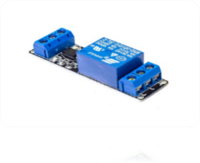

# Figure:5 Relay

A relay switch can be divided into two parts: input and output. The input Section has a coil which generates magnetic field when a small voltage from an Electronic circuit is applied to it. This voltage is called the operating voltage. Commonly used relays are available in different configuration of operating voltages Like 3V, 5V 6V, 9V, 12V, 24V etc. the output section consists of contactors which connect or Disconnect mechanically. In a basic relay there are three contactors: NO, NC and COM. At no input state, the COM is Connected to NC. When the operating voltage is applied the relay coil gets energized And the COM changes contact to NO.

## Soil Moisture Sensor

The Soil Moisture Sensor uses capacitance to measure the water content of soil (by measuring the dielectric permittivity of the soil, which is a function of the water content). Simply insert this rugged sensor into the soil to be tested, and the volumetric water content of the soil is reported in percent.

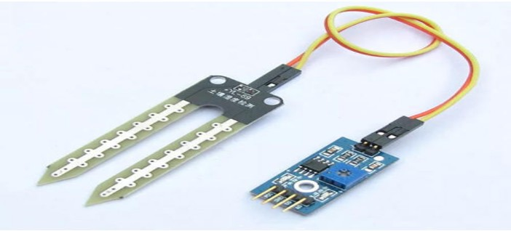

# Figure:6 Soil Moisture Sensor

## Table:4 Pin Configuration of Soil moisture sensor

|  |  |  |
| --- | --- | --- |
| *Sr. number* | *PIN* | *Discription* |
| *1* | *GND* | *Ground* |
| *2* | *VCC* | *Power supply(5V)* |
| *3* | *A0* | *Analog Output* |
| *4* | *D0* | *Digital Output* |

* 1. ***SIM 900 GSM Module***

This is a GSM/GPRS-compatible Quad-band cell phone, which works on a frequency of 850/900/1800/1900MHz and which can be used not only to access the Internet, but also for oral communication (provided that it is connected to a microphone and a small loud speaker) and for SMSs. Externally, it looks like a big package (0.94 inches x 0.94 inches x 0.12 inches) with L-shaped contacts on four sides so that they can be soldered both on the side and at the bottom. Internally, the module is managed by an AMR926EJ-S processor, which controls phone communication, data communication (through an integrated TCP/IP stack), and (through an UART and a TTL serial interface) the communication with the circuit interfaced with the mobile phone network and connecting call to us using GSM itself.

The processor is also in charge of a SIM card (3 or 1,8 V) which needs to be attached to the outer wall of the module.

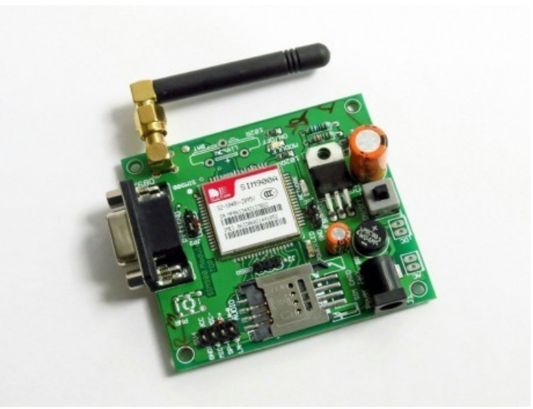

# Figure:7 SIM900A GSM Module

* + 1. ***SIM900A GSM Module Pinout***

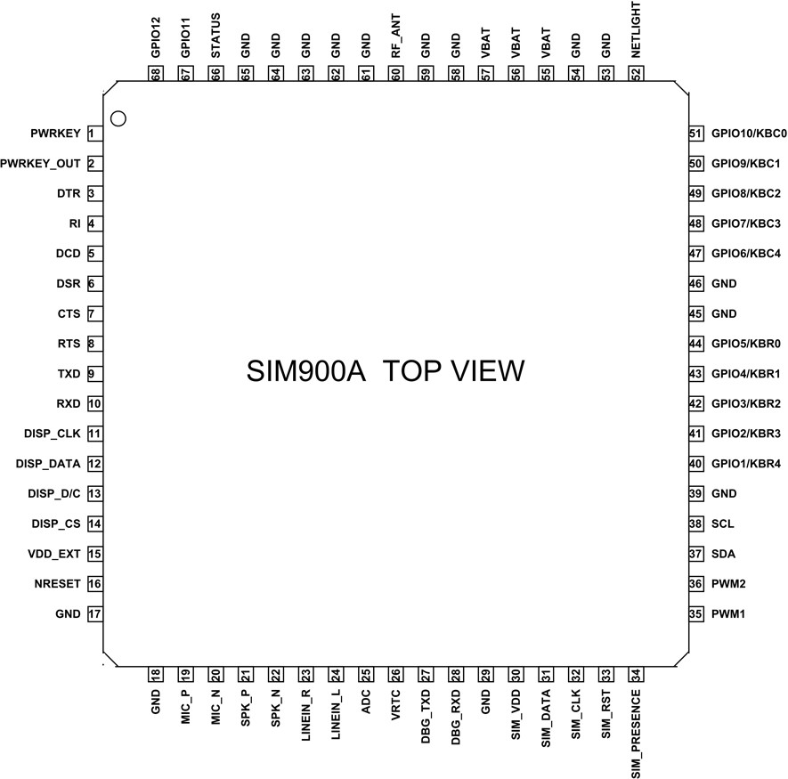

***Figure:8 PIN Diagram of GSM Module***

* + 1. ***SIM900A GSM Module Pinout Configuration***

SIM900A is a 68 terminal device as shown in **pin diagram**. We will describe the function of each pin below.

***Table:5 Pin configuration of GSM Module***

|  |  |  |
| --- | --- | --- |
| ***Pin Number*** | ***Pin Name*** | ***Description*** |
| *1* | *PWRKEY* | *Voltage input for PWRKEY. PWRKEY should be pulled low to power on or power off the system.*  *The user should keep pressing the key for a short time when power on or power off the system because the system need margin time in order to assert the software.* |
| *2* | *PWRKEY_OUT* | *Connecting PWRKEY and PWRKEY_OUT for a short time then release also can power on or power off the module.* |
| *3* | *DTR* | *Data terminal Ready [Serial port ]* |
| *4* | *RI* | *Ring indicator [Serial port ]* |
| *5* | *DCD* | *Data carry detect [Serial port ]* |
| *6* | *DSR* | *Data Set Ready [Serial port ]* |
| *7* | *CTS* | *Clear to send [Serial port ]* |
| *8* | *RTS* | *Request to send [Serial port ]* |
| *9* | *TXD* | *Transmit data [Serial port ]* |
| *10* | *RXD* | *Receive data [Serial port ]* |
| *11* | *DISP _CLK* | *Clock for display [Display interface]* |

|  |  |  |
| --- | --- | --- |
| *12* | *DISP_DATA* | *Display data output [Display interface]* |
| *13* | *DISP _D/C* | *Display data or command select [Display interface]* |
| *14* | *DISP _CS* | *Display Enable [Display interface]* |
| *15* | *VDD_EXT* | *2.8V output power supply* |
| *16* | *NRESET* | *External reset input* |
| *17,18,29,39,45,*  *46,53,54,58,59,*  *61,62,63,64,65* | *GND* | *Ground* |
| *19* | *MIC_P* | *Microphone Positive* |
| *20* | *MIC_N* | *Microphone Negative* |
| *21* | *SPK_P* | *Speaker Positive* |
| *22* | *SPK_N* | *Speaker Negative* |
| *23* | *LINEIN_R* | *Right Channel input [External line inputs are available to directly mix or multiplex externally generated analog signals such as polyphonic tones from an external melody IC or music generated by an FM tuner IC or module.]* |
| *24* | *LINEIN_L* | *Left Channel Input* |

|  |  |  |
| --- | --- | --- |
| *25* | *ADC* | *General purpose analog to digital converter.* |
| *26* | *VRTC* | *Current input for RTC when the battery is not supplied for the system.*  *Current output for backup battery when the main battery is present and the backup battery is in low voltage state.* |
| *27* | *DBG_TXD* | *Transmit pin [Serial interface for debugging and firmware upgrade ]* |
| *28* | *DBG_RXD* | *Receive pin [Serial interface for debugging and firmware upgrade ]* |
| *30* | *SIM_VDD* | *Voltage supply for SIM card* |
| *31* | *SIM_DATA* | *SIM data output* |
| *32* | *SIM_CLK* | *SIM clock* |
| *33* | *SIM_RST* | *SIM reset* |
| *34* | *SIM_PRESENCE* | *SIM detect* |
| *35* | *PWM1* | *PWM Output* |
| *36* | *PWM2* | *PWM Output* |
| *37* | *SDA* | *Serial Data [I2C]* |
| *38* | *SCL* | *Serial Clock [I2C]* |

|  |  |  |
| --- | --- | --- |
| *40,41,42,43,44*  *& 47,48,49,50,51* | *KBR0 to KBR4*  *&*  *KBC4 to KBC0* | *Keypad interface [ROWS & COLUMNS]* |
| *52* | *NETLIGHT* | *Indicate net status* |
| *55,56,57* | *VBAT* | *Three VBAT pins are dedicated to connect the supply voltage. The power supply of SIM900A has to be a single voltage source of VBAT= 3.4V to 4.5V. It must be able to provide sufficient current in a transmit burst which typically rises to 2A.* |
| *60* | *RF_ANT* | *Antenna connection* |
| *66* | *STATUS* | *Indicate working status* |
| *67* | *GPIO 11* | *General Purpose Input/output* |
| *68* | *GPIO 12* | *General Purpose Input/output* |
|  |  |  |

***SIM900A GSM MODULE Features***

* *Single supply voltage: 9V – 12V*
* *Power saving mode: Typical power consumption in SLEEP mode is 1.5mA*
* *Frequency bands:SIM900A Dual-band: EGSM900, DCS1800. The SIM900A can search the two frequency bands automatically. The frequency bands also can be set by AT command.*
* *GSM class: Small MS*
* *GPRS connectivity:GPRS multi-slot class 10 (default) , GPRS multi-slot class 8 (option)*
* *Transmitting power: Class 4 (2W) at EGSM 900, Class 1 (1W) at DCS 1800*
* *Operating Temperature: -30ºC to +80ºC*
* *Storage Temperature: -5ºC to +90ºC*
* *DATA GPRS: download transfer max is 85.6KBps, Upload transfer max 42.8KBps*
* *Supports CSD, USSD, SMS, FAX*
* *Supports MIC and Audio Input*
* *Speaker Input*
* *Features keypad interface*
* *Features display interface*
* *Features Real Time Clock*
* *Supports UART interface*
* *Supports single SIM card*
* *Firmware upgrade by debug port*
* *Communication by using AT commands*

## 7805 Voltage Regulator

A voltage regulator is a system designed to automatically maintain a constant voltage level. A voltage regulator may use a simple feed-forward design or may include negative feedback. It may use an electromechanical mechanism, or electronic components. Depending on the design, it may be used to regulate one or more AC or DC voltages.

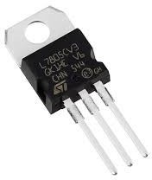Electronic voltage regulators are found in devices such as computer power supplies where they stabilize the DC voltages used by the processor and other elements. In automobile alternators and central power station generator plants, voltage regulators control the output of the plant. In an electric power distribution system, voltage regulators may be

installed at a substation or along

distribution lines so that all customers receive

steady voltage independent of how much

power is drawn from the line.

## Colour Sensor

***Figure:9 7805 Voltage Regulator***

The colour of an object we can see in fact is the chromatic light the object reflects in the white light (sunlight) after it absorbs the rest ones. The white colour is a mixture of various visible colours, which means it includes each coloured light like red (R), yellow (Y), green (G), blue (B), and purple (P). Based on the theory of three primary colours, any colour is made by mixing the three primary colours red, green, and blue.

Thus, knowing the proportion you can get the colour of the tested object. For TCS3200, when a colour filter is selected, it only allows a specific primary colour to pass through and blocks the other two colours. With the light intensity value of the three primary colours, by analysis we can know the colour of light reflected to TCS3200

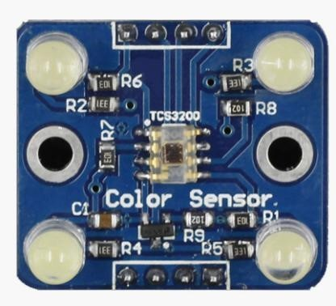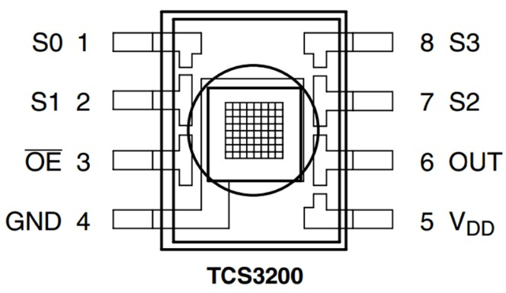

# Figure:10 Colour Sensor

***Figure:11 PIN Diagram of Colour Sensor***

***Table:6 Pin Configuration of Color Sensor***

|  |  |  |
| --- | --- | --- |
| ***PIN NAME*** | ***PIN NUMBER*** | ***DESCRIPTION*** |
| *GND* | *4* | *Power supply ground. All voltages are reference to the ground.* |
| *VCC* | *5* | *Supply voltage* |
| *OE* | *3* | *Enable for FO (Active low)* |
| *OUT* | *6* | *Output frequency (fo)* |
| *S0, S1* | *1, 2* | *Select lines for output frequency scaling* |
| *S2, S3* | *7,8* | *Select lines for photodiode type.* |

***Table:7 Connection For Frequency Scaling of Colour Sensor***

|  |  |  |
| --- | --- | --- |
| *S0* | *S1* | *OUTPUT FREQUENCY SCALING(f0)* |
| *L* | *L* | *Power down* |

|  |  |  |
| --- | --- | --- |
| *L* | *H* | *2%* |
| *H* | *L* | *20%* |
| *H* | *H* | *100%* |

***Table:8 Connection For photodiode type***

|  |  |  |
| --- | --- | --- |
| *S2* | *S3* | *PHOTODIODE TYPE* |
| *L* | *L* | *RED* |
| *L* | *H* | *BLUE* |
| *H* | *L* | *CLEAR (NO FILTER)* |
| *H* | *H* | *GREEN* |

1. ***Soil Testing Kit***

soil testing kit is a chemical which is use to figure out amount of nutrients in soil chemical of soil testing kit is react with Nitrogen, potassium, and phosphorous and give different colour according to these colour we can find the amount of nutrients presence in soil

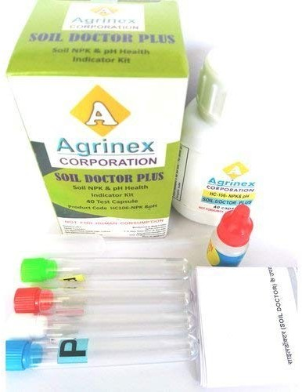

# Figure:12 Soil Testing Kit

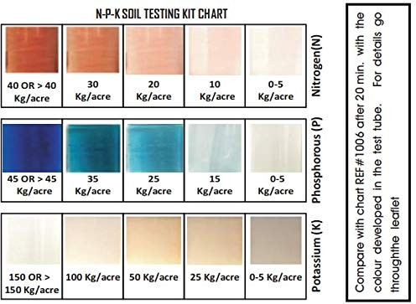

***Figure:13 Colour for nutrients***

## Water Pump

A water pump is a combination of electrical and mechanical device that is

designed to extract underground water . Water pumps are typically driven via the rotation of the crankshaft, although that can be accomplished in a variety of different ways. There are also a number of different styles of pumps that are commonly used.

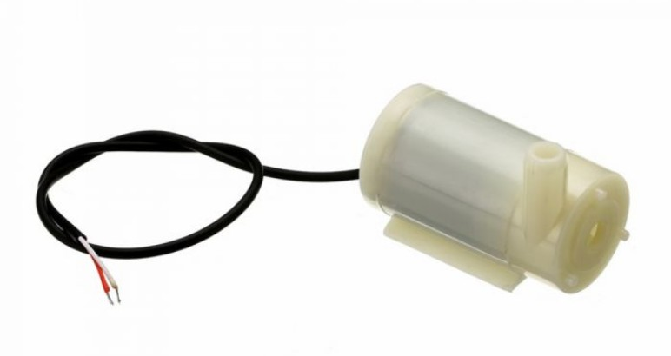

# Figure:14 Water Pump CHAPTER 9

***Advantages and Limitations***

# Advantages:

## Prevents Soil From Getting

It prevents soil from dryness. It automatically sends the message to the user about soil condition and when the soil moisture reaches the emergent point it automatically switch ON the pump and when the soil become enough moist it turns OFF the pump.

## Conserves Water and Time

The main purpose of this project is to save energy and water and also the time of the Farmer. It’s automatically turns ON and OFF by itself according to the input of the sensors and conserves energy and time.

## Conserves Soil from Infertility

It conserves soil from infertility by giving info about the main components of the soil like Sodium, Potassium, and Phosphorous. This is the main feature of the project.

## Gardening Flexibility

If you have a busy schedule, you'll appreciate being able to work in the garden at the same time as the plants are being watered. While one garden section is being watered, you can plant and prune in another area.

# Limitations:

1. *It requires initial evaluation of site specific conditions before selection of appropriate moisture sensor.*
2. *It requires probe to be inserted in the soil. It requires labor to collect the data and maintain the measurement processes.*
3. *The measured values depend on properties of various materials. The correct interpretation and use of moisture data is needed.*
4. *Watermark sensors provide less accuracy in sandy soils due to large particles.*
5. *Watermark sensors are required to be calibrated for each soil types. Tensiometers also require periodic service.*

# CHAPTER 10

***Applications***

* + *TEST SOIL NUTRIENTS*
  + *IN FILD IRRIGATION*
  + *HOME GARDANING*

# CHAPTER 11

***Table:9 Cost of project***

|  |  |  |
| --- | --- | --- |
| ***Sr. number*** | ***Name of component*** | ***Price of component in rupee*** |
| *1* | *Arduino Uno* | *450* |
| *2* | *SIM 900A module* | *950* |
| *3* | *Colour sensor* | *200* |
| *4* | *Soil moisture sensor* | *150* |
| *5* | *Soil testing kit* | *600* |
| *6* | *Relay module* | *100* |
| *7* | *Switch(3)* | *30* |
| *8* | *Adaptor(2)* | *300* |

# CHAPTER 12 CONCLUSION

The application of agriculture networking technology is need of the modern agricultural development, but also an important symbol of the future level of agricultural development; it will be the future direction of agricultural development. After building the agricultural water irrigation system hardware and analyzing and researching the network hierarchy features, functionality and the corresponding software architecture of precision agriculture water irrigation systems, actually applying the internet of things to the highly effective and safe agricultural production has a significant impact on ensuring the efficient use of water resources as well as ensuring the efficiency and stability of the agricultural production. In the Future, this system can be made as an intelligent system, where in the system predicts user actions, rainfall pattern, time to harvest and many more features which will make the system

independent of human operation.

# CHAPTER 13

***Reference***

[1] https://components101.com/ [2]https://[www.arduino.cc/](http://www.arduino.cc/)

1. *https://*[*www.sciencedirect.com/science/article/pii/S0378377412001746*](http://www.sciencedirect.com/science/article/pii/S0378377412001746)
2. *Dr. Narayan G. Hegde, “Water Scarcity and Security in India”, BAIF Development Reseach Foundation, Pune.*
3. *Marvin T. Batte, “Changing computer use in agriculture: evidence from Ohio”, Computers and Electronics in Agriculture, Elsevier science publishers, vol. 47, 1–13, 2005*
4. *Csótó, Magyar, “Information flow in agriculture – through new channels for improved effectiveness”, Journal of Agricultural Informatics 1 (2), 25–34, 2010*
5. *Jin Shen, Song Jingling, Han Qiuyan and Yang Yan, “A Remote Measurement and Control System for Greenhouse Based on GSM-SMS”, Electronic Measurement andInstruments, 2007.ICEMI '07. 8th International Conference*
6. *InduGautam and S.R.N Reddy, “Innovative GSM based Remote Controlled Embedded System for Irrigation”, International Journal of Computer Applications Vol. 47 – No.13, June 2012*